SAP Treasury Term Loan Lifecycle - Executed Through OData
  - ZFS_SB_DYNGATEWAY_O4_API on DS4 / client 100

System: DS4, client 100 (DS4_100_NIIF)
Executed by: FS_DEV3, driven from SAP GUI transaction /IWFND/GW_CLIENT
Date: 11.09.2026
Service base URL: https://vhnlqds4ap01.sap.niififl.in:44300/sap/opu/odata4/sap/zfs_sb_dyngateway_o4_api/srvd_a2x/sap/zfs_sd_dyngateway/0001/DynGateway/com.sap.gateway.srvd_a2x.zfs_sd_dyngateway.v0001

Scope
The complete lifecycle of an SAP Treasury term loan was executed end to end through the dynamic OData gateway rather than by driving the transaction codes: create the deal, settle it, post its flows (TBB1), run month-end accrual/deferral (TPM44) and valuation (TPM1), and write a fee row to a custom table.

Result Summary
Test Case | Step | Business Result | Verdict
TC-01 | Create term loan - BAPI_FTR_IRATE_DEALCREATE | Deal 0000000160440 | PASS
TC-02 | Settle the transaction - BAPI_FTR_IRATE_SETTLE | Settled (activity 00002) | PASS
TC-03 | TBB1 posting - RFTBBB00 via SUBM / JOB mode | FI document 0600000270 | PASS
TC-04 | TPM44 accrual/deferral - RTPM_ACCRUAL_DEFERRAL | FI documents 0600000271 + 0600000272 (849.32 INR) | PASS (after filter correction)
TC-05 | TPM1 valuation - RTPM_TRL_VALUATION | No write-ups/downs - nothing to post | PASS
TC-06 | New row in ZSGSLCTR_FEEDATA | 1 row inserted | PASS

Gateway Enhancements Required
Two changes to the gateway were needed before the standard SAP reports could be driven through OData. Both were activated with zero messages on transport DS4K907263.

1. Namespace guard removed - ZCL_FS_SLC_GW_SUBMIT
prepare_plan refused any program outside the Z*/Y* namespace, which blocked RFTBBB00, RTPM_ACCRUAL_DEFERRAL and RTPM_TRL_VALUATION outright. It was removed with the requester's explicit approval.
Diagnostic trap worth recording: that guard and the TRDIR-SUBC check raised the SAME message 027, 'Program &1 does not exist or is not executable'. Probing with RSPARAM - which plainly exists and is executable - therefore produced a misleading error.
Security position after the change: the allow-list remains the real control. Nothing runs unless an administrator registered it with ALLOW_WRITE and IS_ACTIVE, S_PROGRAM is still checked against the program's authorisation group, and SUBC='1' still rejects non-executable programs. The trade-off is a wider blast radius: any registered standard report is now runnable.

14-SUBM-namespace-guard-confirmed-RSPARAM-refused.png - the guard rejecting a standard program before the change
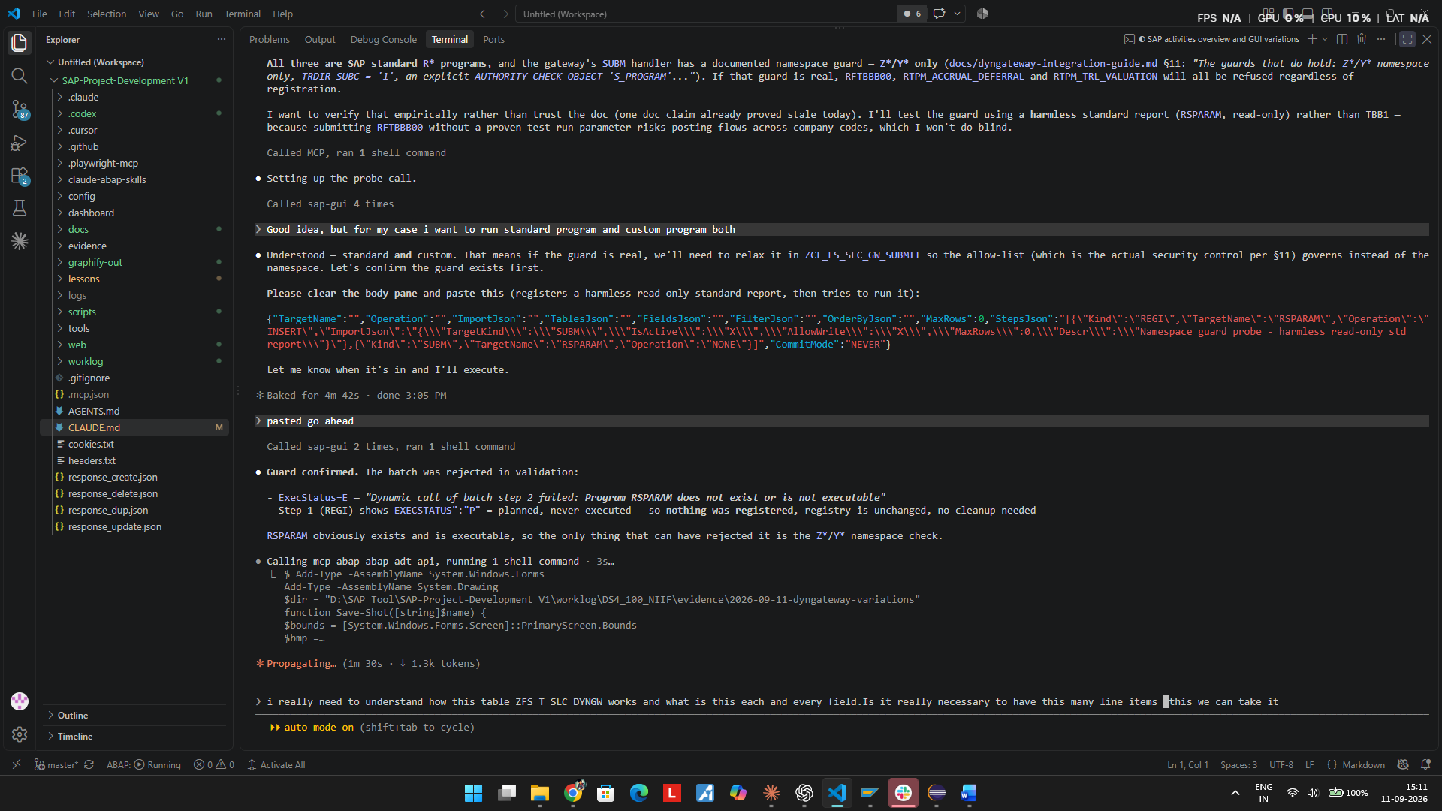

2. New JOB capture mode - ZFS_RFC_DYNGW_SUBMIT
The existing modes (SALV/LIST/MEMO/NONE) all SUBMIT synchronously into the DESTINATION 'NONE' RFC session, where there is no GUI and sy-batch is not set. A report that can render its own output takes its dialog path and terminates the work process - RFTBBB00 did exactly this after 31 seconds.
JOB mode runs the report as a genuine background job, where sy-batch = 'X': JOB_OPEN, SUBMIT VIA JOB, JOB_CLOSE, COMMIT WORK, poll TBTCO, then read the step's spool via TBTCP-LISTIDENT and RSPO_RETURN_ABAP_SPOOLJOB. The spool comes back to the caller as ROWSJSON, one JSON object per line, and the envelope carries JOBNAME, JOBCOUNT, JOBSTATUS and SPOOLID.
Poll budget is 400 seconds. A job exceeding it is not lost - it keeps running and the envelope returns its job name for follow-up.

TC-01 - Create term loan - BAPI_FTR_IRATE_DEALCREATE
Action: POST https://vhnlqds4ap01.sap.niififl.in:44300/sap/opu/odata4/sap/zfs_sb_dyngateway_o4_api/srvd_a2x/sap/zfs_sd_dyngateway/0001/DynGateway/com.sap.gateway.srvd_a2x.zfs_sd_dyngateway.v0001/CallFunctionModule?sap-client=100

Request (JSON)
{"TargetName":"BAPI_FTR_IRATE_DEALCREATE","ImportJson":"{\"GENERALCONTRACTDATA\":{\"COMPANY_CODE\":\"1000\",\"PRODU
CT_TYPE\":\"22A\",\"TRANSACTION_TYPE\":\"100\",\"PARTNER\":\"0700000453\",\"CONTRACT_DATE\":\"2026-01-01\",\"VALUAT
ION_CLASS\":\"0001\"},\"INTERESTRATEINSTRUMENT\":{\"CURRENCY\":\"INR\",\"START_TERM\":\"2026-01-01\",\"END_TERM\":\
"2026-12-31\",\"NOMINAL_AMOUNT\":100000,\"INTEREST_RATE_STRUCTURE\":\"1\",\"INTEREST_CONDITION_TYPE\":\"1200\",\"IN
TEREST_RATE\":10,\"INTEREST_CALC_METH\":\"3\",\"FREQUENCY_CATEGORY\":\"3\",\"FREQUENCY\":1,\"FREQUENCY_UNIT\":\"2\"
,\"INTEREST_CALENDAR_ID\":\"01\",\"EFFECTIVE_FROM\":\"2026-01-01\",\"REPAY_STRUCTURE\":\"1\",\"REPAY_CONDITION_TYPE
\":\"1120\"},\"TESTRUN\":\"\"}","TablesJson":"{\"CONDITION\":[],...,\"RETURN\":[]}"}

Response
TESTRUN=X -> ExecStatus=S, ExportJson {"COMPANYCODE":"1000","FINANCIALTRANSACTION":"\\INTERN\\"} (placeholder = c
lean dry run)
REAL (ExecuteBatch, CommitMode=AUTO) -> ExecStatus=S, ResultCount=1

Expected
A 22A/100 term loan for CoCd 1000, partner 0700000453, INR 100,000 at 10% fixed with MONTHLY interest and bullet repayment at 31.12.2026.

Actual
PASS - deal 0000000160440 created (VTBFHA). Condition table confirms: interest condition type 1200 at 10.0000000 with FREQUENCY=1 / FREQUENCY_UNIT=0 (Months), and repayment condition type 1120 at 100% due 31.12.2026.

Key modelling note: the simple BAPI_FTR_IRATE_CREATE cannot express monthly interest. DEALCREATE exposes the wizard-style fields INTEREST_RATE_STRUCTURE=1 (Fixed), FREQUENCY_CATEGORY=3 (Monthly), FREQUENCY=1, FREQUENCY_UNIT=2 (Months, domain T_ARHYTM_UNIT) and REPAY_STRUCTURE=1 (Final Repayment). The CONDITION/MAINFLOW/PAYMENTDETAIL tables were sent EMPTY - the system derives them.

Verdict: PASS

Evidence
07-REGI-FTR-BAPIs-ready.png
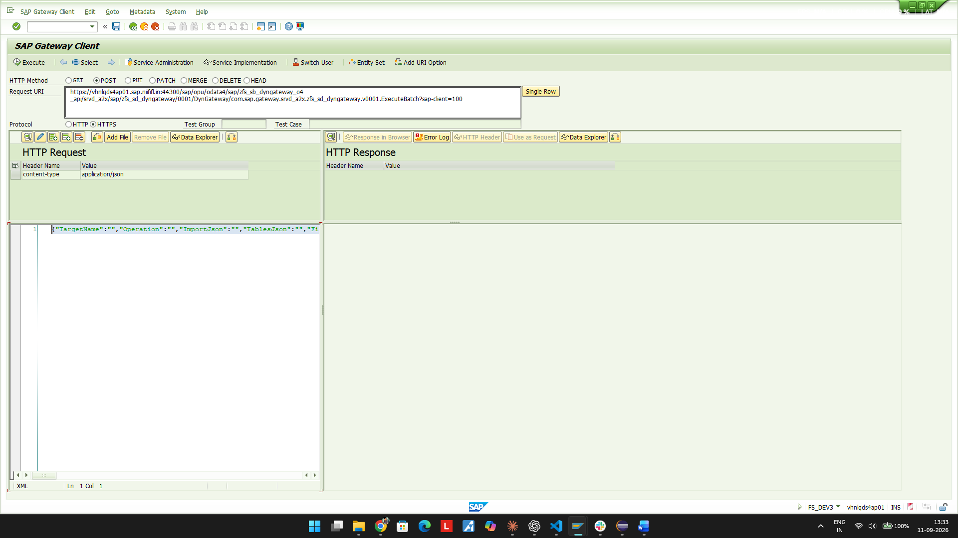
08-DEALCREATE-testrun-ready.png
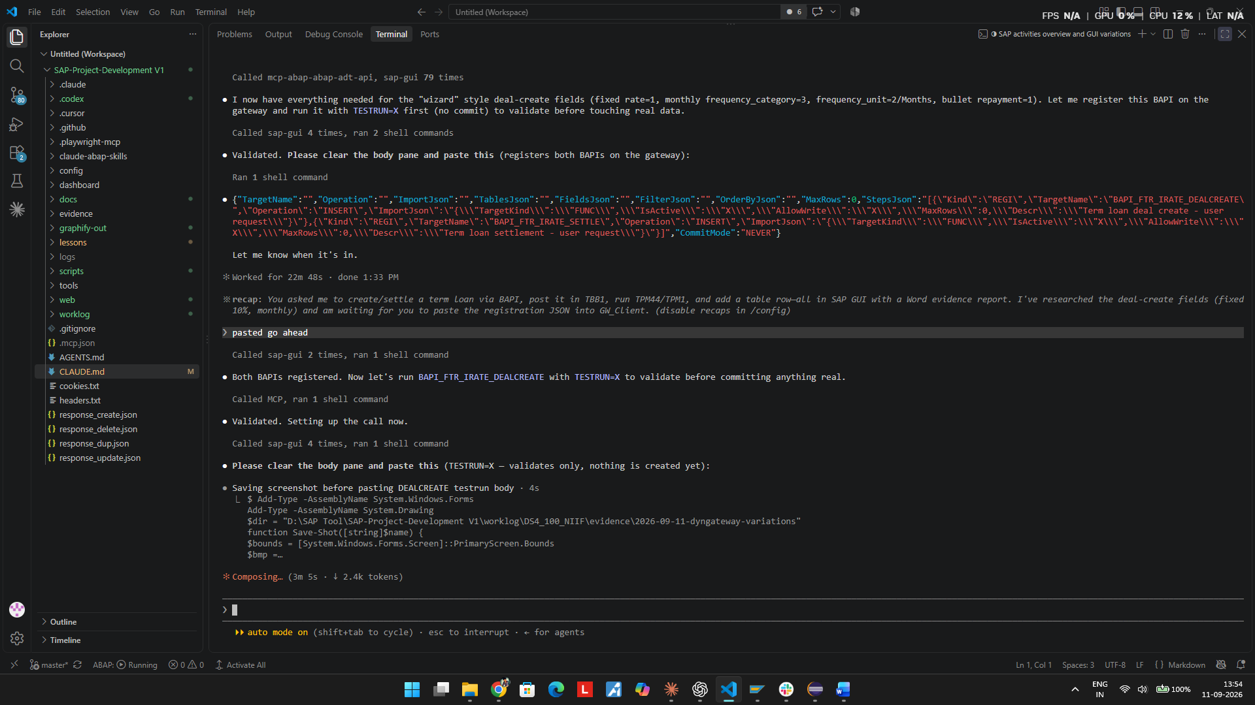
09-DEALCREATE-real-commit-ready.png
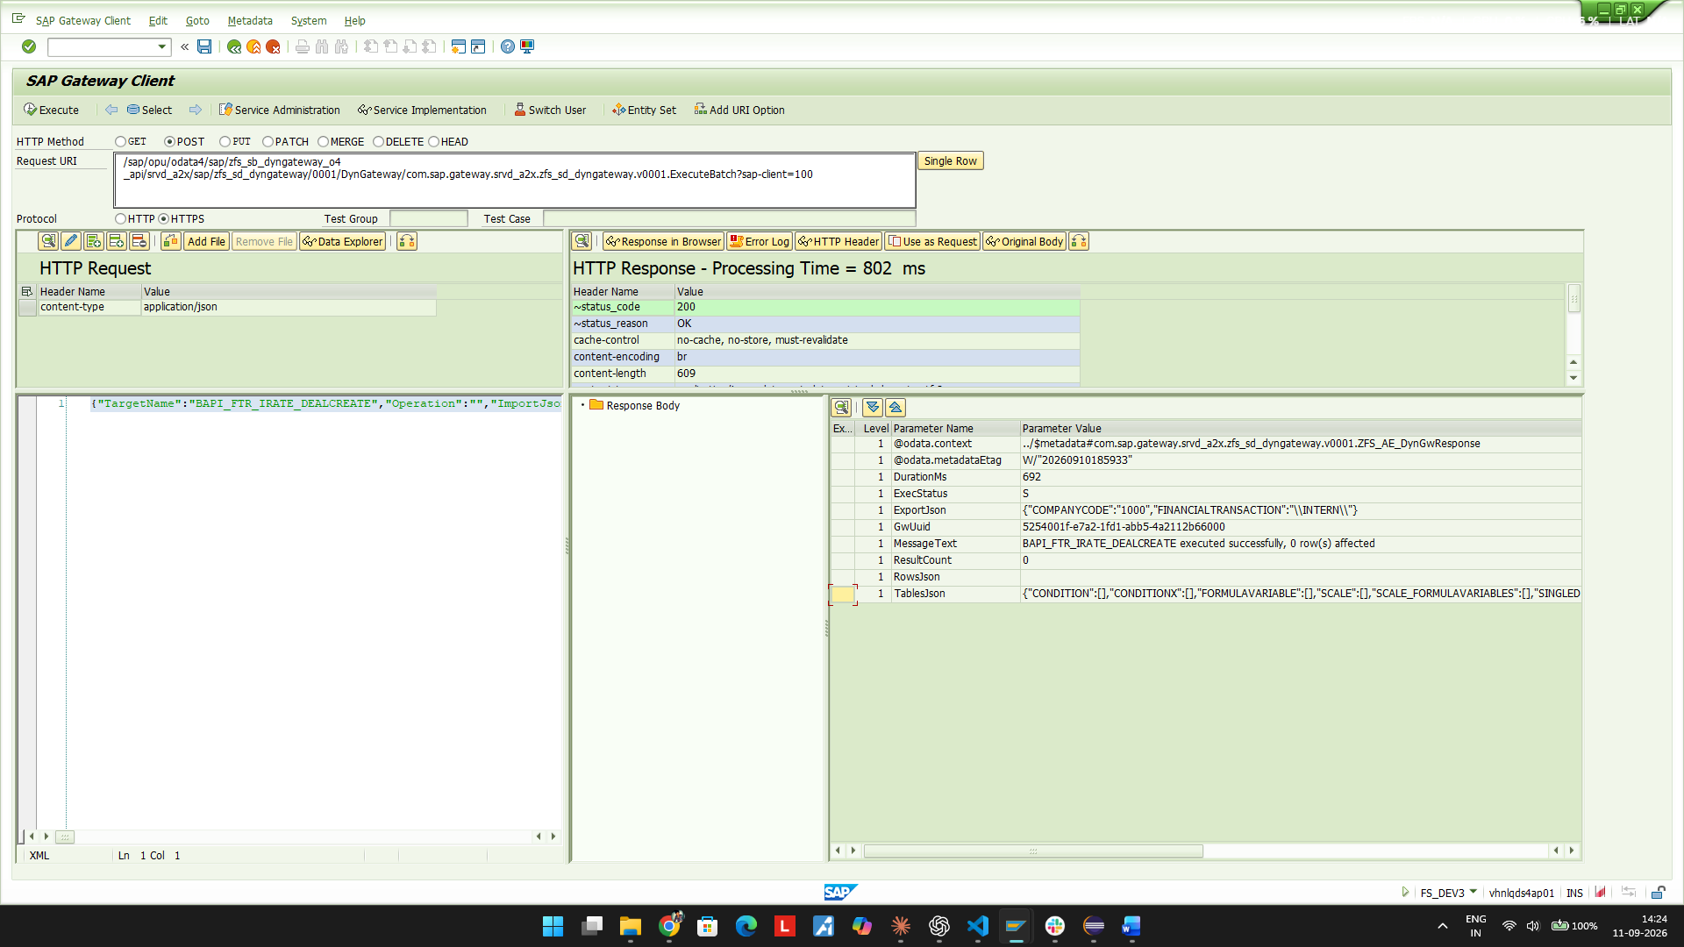
10-DEALCREATE-VTBFHA-new-deal-160440.png
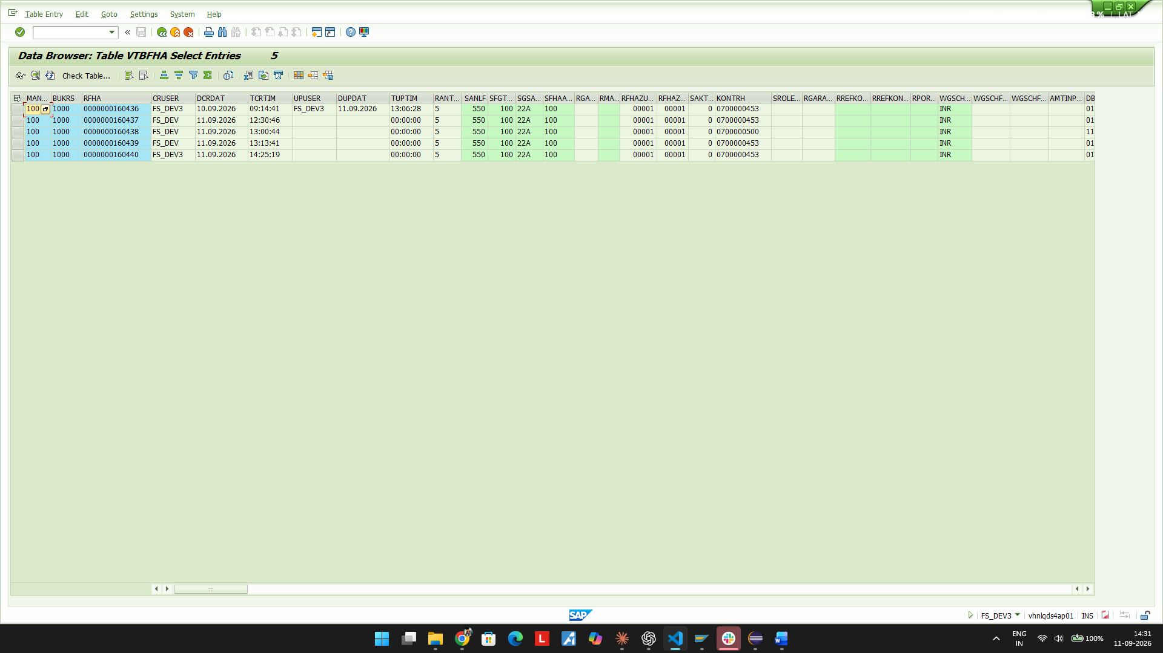
11-DEALCREATE-condition-table-monthly-confirmed.png
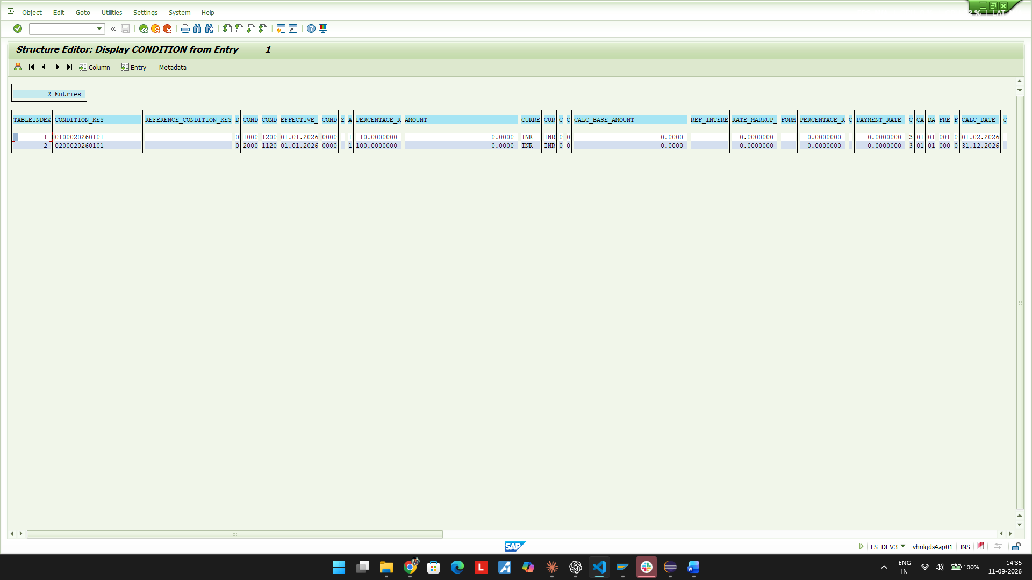

TC-02 - Settle the transaction - BAPI_FTR_IRATE_SETTLE
Action: POST https://vhnlqds4ap01.sap.niififl.in:44300/sap/opu/odata4/sap/zfs_sb_dyngateway_o4_api/srvd_a2x/sap/zfs_sd_dyngateway/0001/DynGateway/com.sap.gateway.srvd_a2x.zfs_sd_dyngateway.v0001/ExecuteBatch?sap-client=100

Request (JSON)
{"StepsJson":"[{\"Kind\":\"FUNC\",\"TargetName\":\"BAPI_FTR_IRATE_SETTLE\",\"ImportJson\":\"{\\\"COMPANYCODE\\\":\\
\"1000\\\",\\\"FINANCIALTRANSACTION\\\":\\\"0000000160440\\\",\\\"TESTRUN\\\":\\\"\\\"}\",\"TablesJson\":\"{\\\"RET
URN\\\":[]}\"}]","CommitMode":"AUTO"}

Response
TESTRUN=X -> ExecStatus=S, RETURN carried only TYPE="W" (FTR_GUI 220, partner validity) - a warning, not an error.
REAL -> ExecStatus=S, ResultCount=1

Expected
Deal 0000000160440 moves from created to settled.

Actual
PASS - VTBFHAZU shows a second activity row: activity 00002, activity category 20 (settled), created 14:48:21, alongside the original activity 00001 / category 10 (created).

Verdict: PASS

Evidence
12-SETTLE-testrun-ready.png
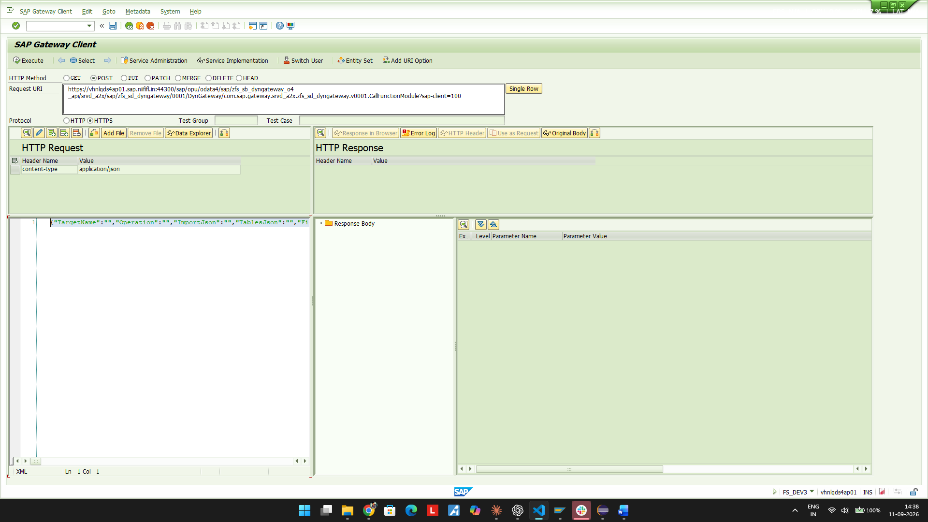
12b-SETTLE-testrun-response.png
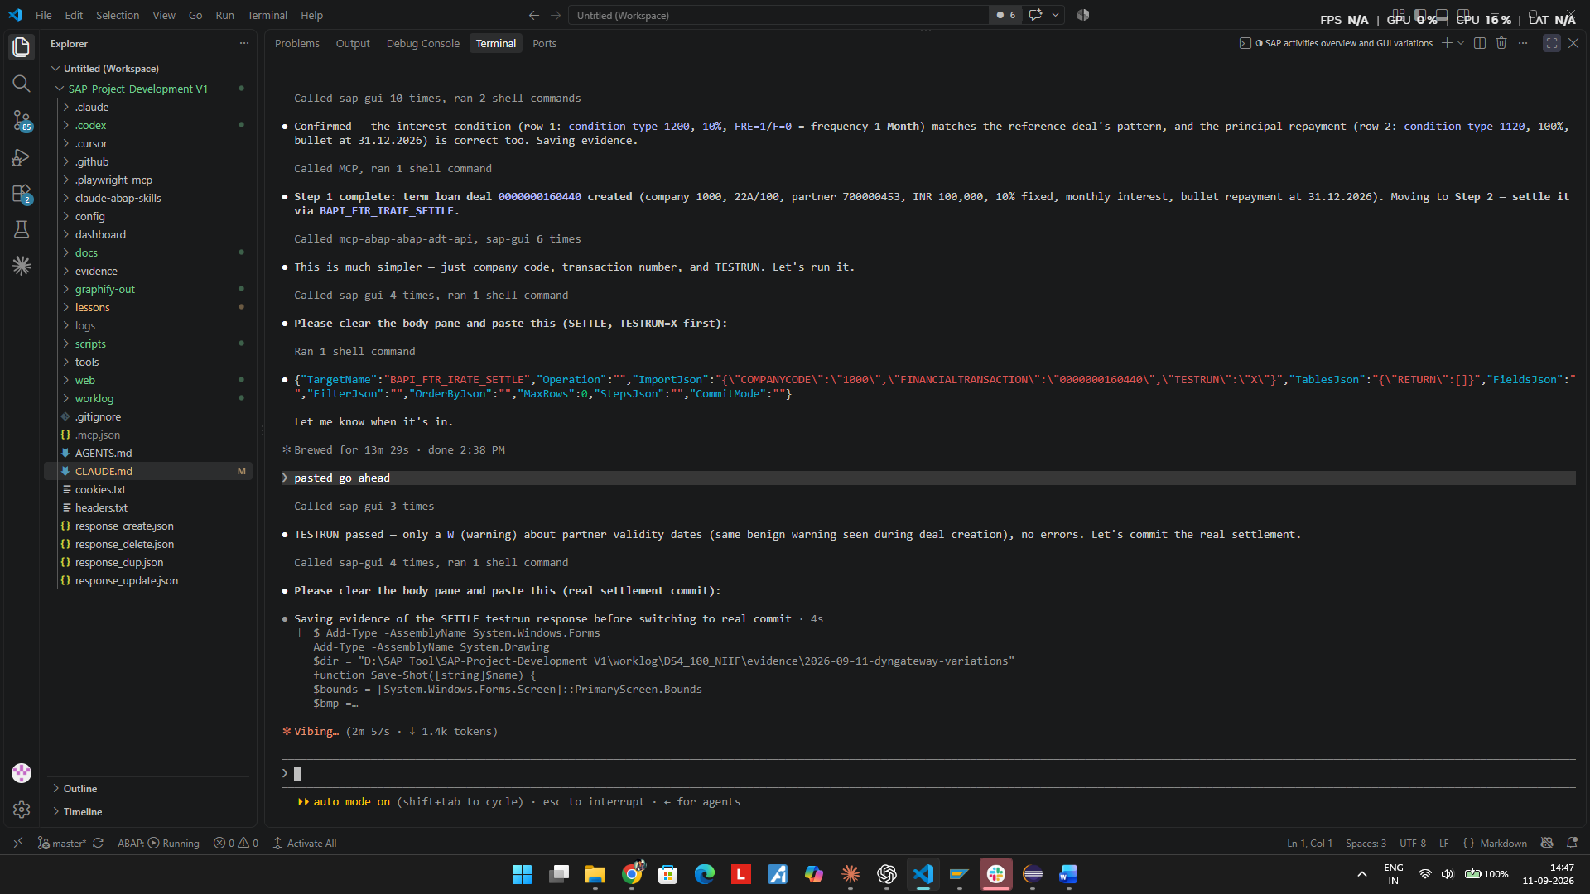
13-SETTLE-VTBFHAZU-activity-confirmed.png
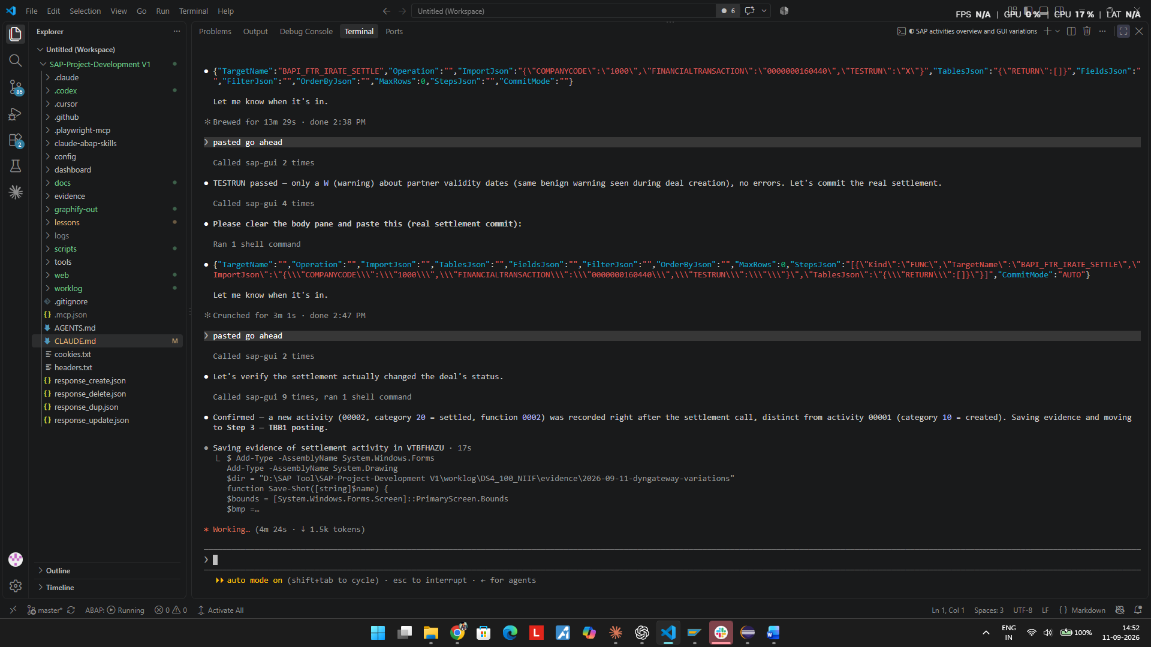

TC-03 - TBB1 posting - RFTBBB00 via SUBM / JOB mode
Action: POST https://vhnlqds4ap01.sap.niififl.in:44300/sap/opu/odata4/sap/zfs_sb_dyngateway_o4_api/srvd_a2x/sap/zfs_sd_dyngateway/0001/DynGateway/com.sap.gateway.srvd_a2x.zfs_sd_dyngateway.v0001/ExecuteBatch?sap-client=100

Request (JSON)
{"StepsJson":"[{\"Kind\":\"SUBM\",\"TargetName\":\"RFTBBB00\",\"Operation\":\"JOB\",\"FilterJson\":\"[{\\\"Field\\\
":\\\"S_BUKRS\\\",\\\"Op\\\":\\\"EQ\\\",\\\"Low\\\":\\\"1000\\\"},{\\\"Field\\\":\\\"S_RFHA\\\",\\\"Op\\\":\\\"EQ\\
\",\\\"Low\\\":\\\"0000000160440\\\"},{\\\"Field\\\":\\\"P_DZTERM\\\",\\\"Op\\\":\\\"EQ\\\",\\\"Low\\\":\\\"2026010
1\\\"},{\\\"Field\\\":\\\"P_BUDAT\\\",\\\"Op\\\":\\\"EQ\\\",\\\"Low\\\":\\\"20260101\\\"},{\\\"Field\\\":\\\"P_TEST
\\\",\\\"Op\\\":\\\"EQ\\\",\\\"Low\\\":\\\"X\\\"}]\",\"MaxRows\":200}]","CommitMode":"NEVER"}

Response
TEST RUN -> S, 10 spool lines, 2.4 s. Envelope: JOBNAME ZFSGW_RFTBBB00, JOBCOUNT 16151600, JOBSTATUS F, SPOOLID 22
781
|Records passed | 1|
| |1000|160440|Test run was successful|22A |TL - Disbursements|100 |Disbursement-Term Loan Plan|
REAL RUN (P_TEST="") -> S, 10 lines, JOBCOUNT 16182800, SPOOLID 22783
| |1000|160440|Transactions were updated successfully|22A |TL - Disbursements|100 |Disbursement-Term Loan Pla
n|

Expected
Treasury flows for deal 0000000160440 posted with due date and posting date both 01.01.2026.

Actual
PASS - FI document 0600000270 created (BKPF: CoCd 1000, doc type T1, AWTYP TR-TM, posting date 01.01.2026, entered 11.09.2026 by FS_DEV3).

This step is what forced the JOB capture mode. Run synchronously (SALV/LIST), RFTBBB00 terminated the RFC work process after 31 s with 020 "connection closed (no data)".

Verdict: PASS

TC-04 - TPM44 accrual/deferral - RTPM_ACCRUAL_DEFERRAL
Action: POST https://vhnlqds4ap01.sap.niififl.in:44300/sap/opu/odata4/sap/zfs_sb_dyngateway_o4_api/srvd_a2x/sap/zfs_sd_dyngateway/0001/DynGateway/com.sap.gateway.srvd_a2x.zfs_sd_dyngateway.v0001/ExecuteBatch?sap-client=100

Request (JSON)
{"StepsJson":"[{\"Kind\":\"SUBM\",\"TargetName\":\"RTPM_ACCRUAL_DEFERRAL\",\"Operation\":\"JOB\",\"FilterJson\":\"[
{\\\"Field\\\":\\\"SO_BUKRS\\\",\\\"Op\\\":\\\"EQ\\\",\\\"Low\\\":\\\"1000\\\"},{\\\"Field\\\":\\\"SO_OTCNR\\\",\\\
"Op\\\":\\\"EQ\\\",\\\"Low\\\":\\\"0000000160440\\\"},{\\\"Field\\\":\\\"P_KEYDAT\\\",\\\"Op\\\":\\\"EQ\\\",\\\"Low
\\\":\\\"20260131\\\"},{\\\"Field\\\":\\\"P_TEST\\\",\\\"Op\\\":\\\"EQ\\\",\\\"Low\\\":\\\"X\\\"}]\",\"MaxRows\":20
0}]","CommitMode":"NEVER"}

Response
TEST RUN -> S, 25 spool lines, 2.3 s. SPOOLID 22788
|Records passed Header | 2|
|Records passed Position| 4|
| 160440 1000 001 Accrual/deferral 31.01.2026 IndAS
|40 106070 Int Receivable - TL Loan: Accruals: Revenue 849.32 INR
|50 301170 Interest Income - TL Loan: Accruals: Revenue 849.32- INR
| 160440 1000 001 Accrual/deferral reset 01.02.2026 IndAS
|40 301170 Interest Income - TL Loan: Reset Accruals: Revenue 849.32 INR
|50 106070 Int Receivable - TL Loan: Reset Accruals: Revenue 849.32- INR
REAL RUN (P_TEST="") -> S, 25 lines, 2.2 s

Expected
One month of interest accrued at the first month-end from the start date (31.01.2026), with reset at 01.02.2026, for deal 0000000160440 only.

Actual
PASS - FI documents 0600000271 (posting date 31.01.2026) and 0600000272 (01.02.2026) created.

Amount verified independently: 100,000 x 10% x 31/365 = 849.32 INR - exactly 31 days of January on act/365.

IMPORTANT - a wrong filter was caught here before the real run. The first attempt used SO_DEALN, which the report silently ignored: it processed 2,055 positions across the whole company code (warnings for unrelated deals 110001..., product type 20A) and ran 301 s. The correct field for an OTC transaction is SO_OTCNR. With it, the run was scoped to 1 deal and took 2.3 s. The bad run was a TEST run, so nothing was posted.

Verdict: PASS (after filter correction)

TC-05 - TPM1 valuation - RTPM_TRL_VALUATION
Action: POST https://vhnlqds4ap01.sap.niififl.in:44300/sap/opu/odata4/sap/zfs_sb_dyngateway_o4_api/srvd_a2x/sap/zfs_sd_dyngateway/0001/DynGateway/com.sap.gateway.srvd_a2x.zfs_sd_dyngateway.v0001/ExecuteBatch?sap-client=100

Request (JSON)
{"StepsJson":"[{\"Kind\":\"SUBM\",\"TargetName\":\"RTPM_TRL_VALUATION\",\"Operation\":\"JOB\",\"FilterJson\":\"[{\\
\"Field\\\":\\\"SO_BUKRS\\\",\\\"Op\\\":\\\"EQ\\\",\\\"Low\\\":\\\"1000\\\"},{\\\"Field\\\":\\\"SO_OTCNR\\\",\\\"Op
\\\":\\\"EQ\\\",\\\"Low\\\":\\\"0000000160440\\\"},{\\\"Field\\\":\\\"KEYDATE\\\",\\\"Op\\\":\\\"EQ\\\",\\\"Low\\\"
:\\\"20260131\\\"},{\\\"Field\\\":\\\"RKEYDATE\\\",\\\"Op\\\":\\\"EQ\\\",\\\"Low\\\":\\\"20260201\\\"},{\\\"Field\\
\":\\\"VALCAT\\\",\\\"Op\\\":\\\"EQ\\\",\\\"Low\\\":\\\"2\\\"},{\\\"Field\\\":\\\"P_FIDAT\\\",\\\"Op\\\":\\\"EQ\\\"
,\\\"Low\\\":\\\"20260131\\\"},{\\\"Field\\\":\\\"P_RFIDAT\\\",\\\"Op\\\":\\\"EQ\\\",\\\"Low\\\":\\\"20260201\\\"},
{\\\"Field\\\":\\\"X_SIMULA\\\",\\\"Op\\\":\\\"EQ\\\",\\\"Low\\\":\\\"X\\\"}]\",\"MaxRows\":200}]","CommitMode":"NE
VER"}

Response
TEST RUN -> S, 10 spool lines, 2.2 s. SPOOLID 22792
|Records passed | 1|
| |1000|001| 1|22A |160440 |The valuation of the position resulted in no write-ups or write-downs
REAL RUN (X_SIMULA="") -> S, 10 lines, 2.2 s - same result, no documents

Expected
Month-end valuation at 31.01.2026 with reset at 01.02.2026 for deal 0000000160440.

Actual
PASS - the report is correctly scoped to the single deal and reports no write-ups or write-downs, so it posts nothing.

This is the functionally correct answer, not a failure: a plain fixed-rate term loan carried at amortised cost has no market-value movement to revalue. Its economics surface as interest accrual, which TC-04 posted.

TPM1 has no P_TEST parameter - its test flag is X_SIMULA, and its valuation category VALCAT must be set (2 = Mid-Year Valuation with Reset was used, mirroring the TPM44 accrual+reset pattern).

Verdict: PASS

TC-06 - New row in ZSGSLCTR_FEEDATA
Action: POST https://vhnlqds4ap01.sap.niififl.in:44300/sap/opu/odata4/sap/zfs_sb_dyngateway_o4_api/srvd_a2x/sap/zfs_sd_dyngateway/0001/DynGateway/com.sap.gateway.srvd_a2x.zfs_sd_dyngateway.v0001/ExecuteTableCrud?sap-client=100

Request (JSON)
{"TargetName":"ZSGSLCTR_FEEDATA","Operation":"INSERT","ImportJson":"[{\"ZTYPE\":\"01\",\"ZFEE_TYPE\":\"F12\",\"ZOTT
K_NO\":\"999999\",\"ZDTTK_NO\":\"\",\"ZSGSART\":\"\",\"ZCAT\":\"02\",\"ZCODE\":\"01\",\"ZB_AMT\":100000.00,\"ZRATE\
":0,\"ZDAY\":\"\",\"ZAMT\":1000.00,\"ZF_AMT\":1000.00,\"ZCREATED_BY\":\"FS_DEV3\",\"ZCREATED_DATE\":\"2026-09-11\",
\"ZCREATED_TIME\":\"17:00:00\"}]"}

Response
ExecStatus=S, ResultCount=1

Expected
One row inserted with the values supplied by the requester.

Actual
PASS - verified by SELECT: ZTYPE 01, ZFEE_TYPE F12, ZOTTK_NO 999999, ZCAT 02, ZCODE 01, ZB_AMT 100000, ZRATE 0, ZAMT 1000, ZF_AMT 1000, ZCREATED_BY FS_DEV3.

The three ZCREATED_* audit fields were populated in addition to the requested field list, matching the table convention.

Verdict: PASS

Evidence
20-FEEDATA-row-inserted-response.png
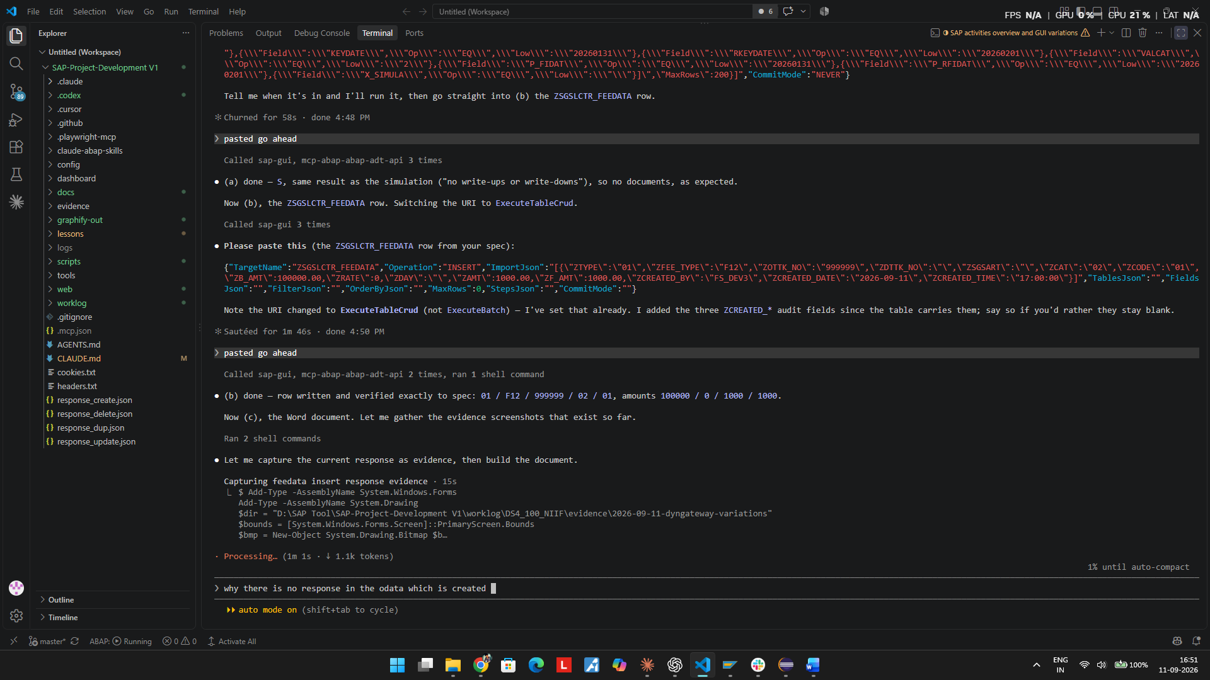

Objects and Data Left on the System
Business data created: deal 0000000160440 and its settlement; FI documents 0600000270 (TBB1), 0600000271 and 0600000272 (TPM44); one row in ZSGSLCTR_FEEDATA (ZOTTK_NO 999999).
Gateway allow-list rows now active and WRITE-capable: BAPI_FTR_IRATE_DEALCREATE, BAPI_FTR_IRATE_SETTLE, RFTBBB00, RTPM_ACCRUAL_DEFERRAL, RTPM_TRL_VALUATION, plus RSPARAM (probe only) and RS_REFRESH_FROM_SELECTOPTIONS (read-only helper).
RECOMMENDED FOLLOW-UP: with the namespace guard removed, these registrations mean any gateway caller can create and settle treasury deals and post treasury flows. Clear IS_ACTIVE on the write-capable rows once testing is complete, and delete the RSPARAM probe row.

Lessons recorded in lessons/lessons-ledger.md: L-359 (namespace guard and its misleading shared message) and L-360 (dialog-capable reports cannot run in the SUBM RFC session; JOB mode is the fix).

